**Task 1: Algorithm Development Task: Inventory Recording System**

Start

For each item in inventory

Item id=1 , Current stock =30

Forecasted demand =105,

reorder cost/unit=3 , Reorder batch size=20

Item_id , current_stock, forecasted_demand,reorder_cost_per_unit,reorder_batch_size

Calculate Shortage:

Shortage=forecasted_demand – current stock

Shortage =105-30 = 75

Shortage > 0

Yes No

Calculate units_to_order

Units_to_order = 0

Reorder_cost = units_to_order * reorder_cost_per_unit

Reorder cost =

80 * 3= 240( 75 rounded to 80)

Store reorder plan for item

Repeat for all items

Return order plan

End

**Algorithm Explanation**

Let explain the algorithm with an example

Begin the process for analyzing the inventory to calculate reorder quantities.

Each item in the inventory

item_id

current_stock (number of items currently in stock)

forecasted_demand (estimated demand for the item)

reorder_cost_per_unit (cost per unit to reorder)

reorder_batch_size (minimum units that must be ordered in one batch).

Here,

Item id=1 , Current stock =30

Forecasted demand =105,

reorder cost/unit=3 , Reorder batch size=20

To Calculate shortage:

Shortage = Forecasted_demand – Current stock

Shortage = 105 - 30 = 75

Units to Order = Round 75 to next multiple of 20(Reorder batch size) → 80

If units_to_order > 0:

Use the formula:  
reorder_cost = units_to_order * reorder_cost_per_unit

Reorder Cost = 80 * 3 = 240

End  
Terminate the process after processing all inventory items.

**Database Task: Employee Management System**

**1.Database Schema :**

**Employee Table**

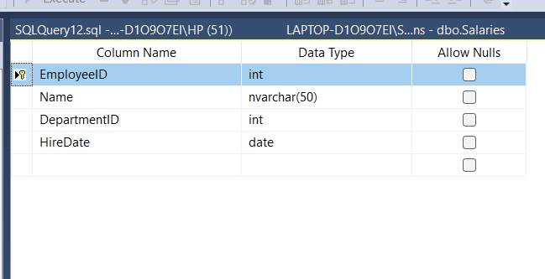

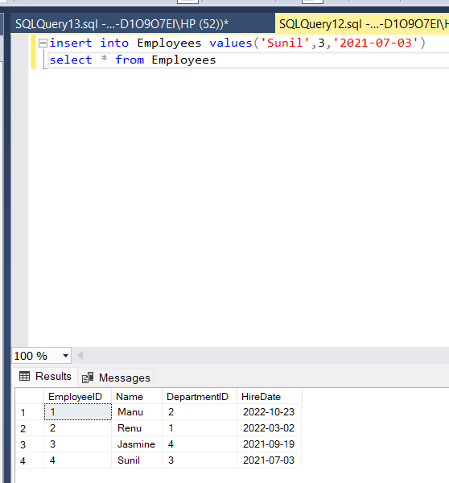

**Departments Table**

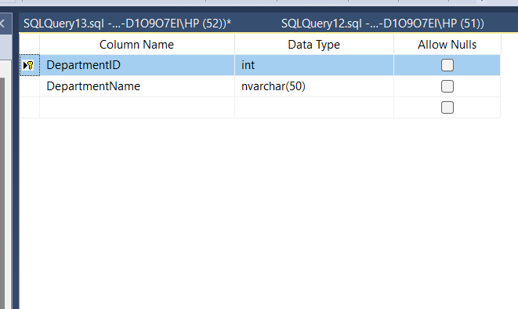

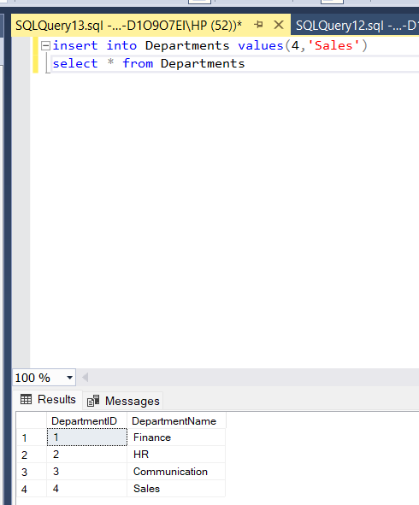

**Salaries Table**

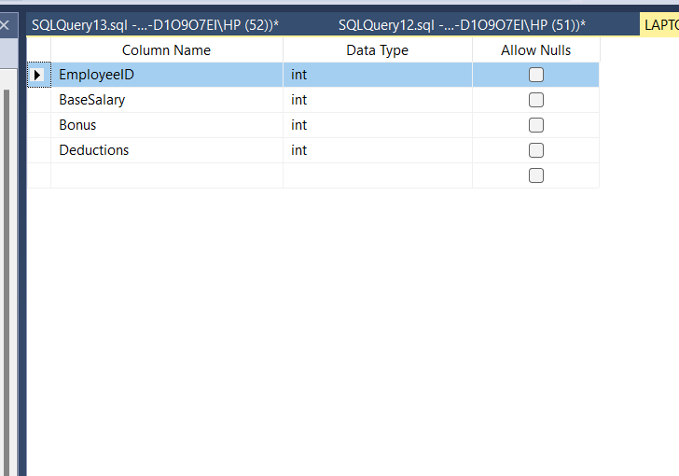

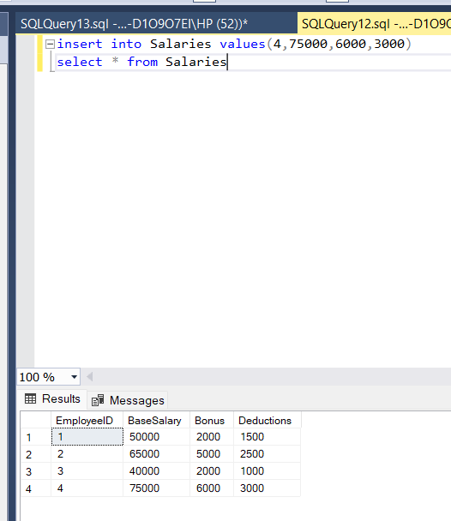

**2.SQL Queries**

* List all employees along with their department names

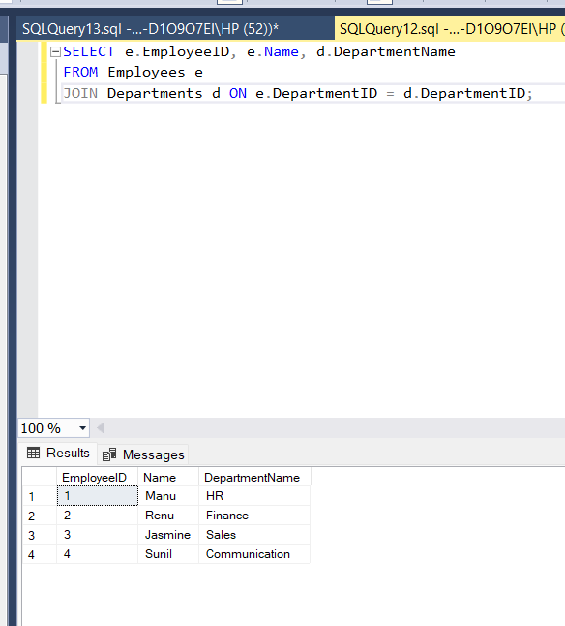

* Calculate the net salary for each employee using:

Net Salary = Base salary + Bonus -Deductions

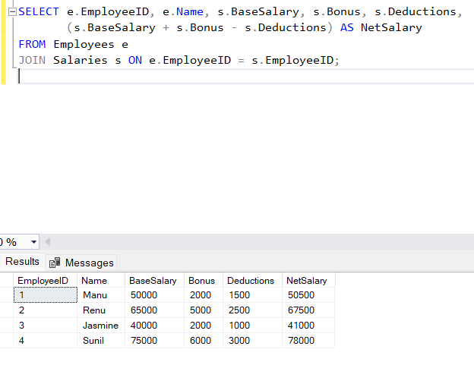

* Identify the department with the highest average salary.

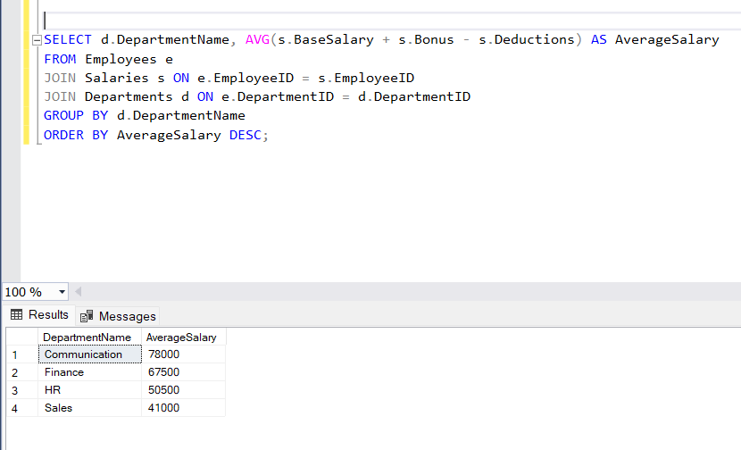

**3.Stored Procedure**

A procedure to insert a new employee into the Employees table ,ensuring valid DepartmentID and other constarints

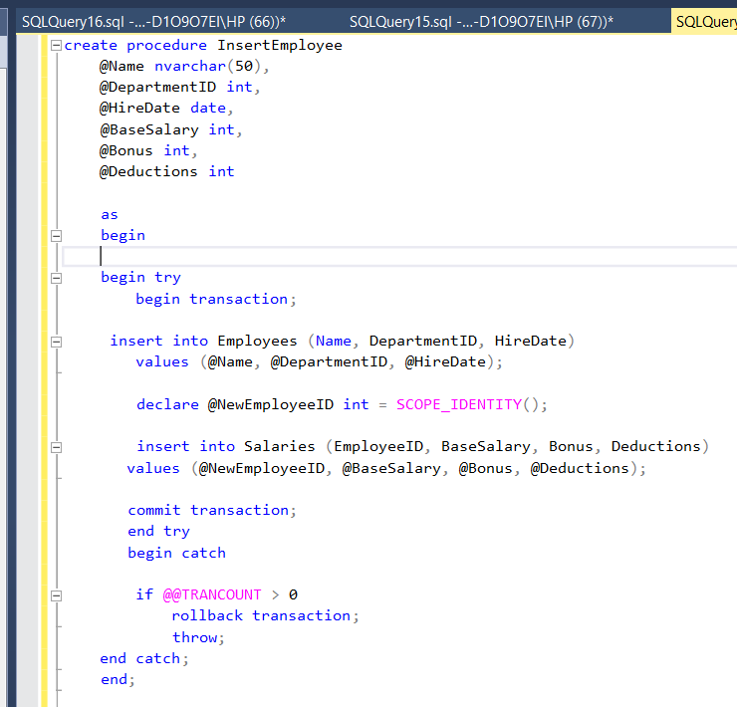

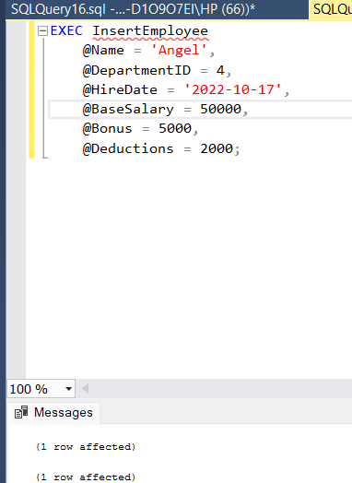

* A procedure to update the salary details of an employee

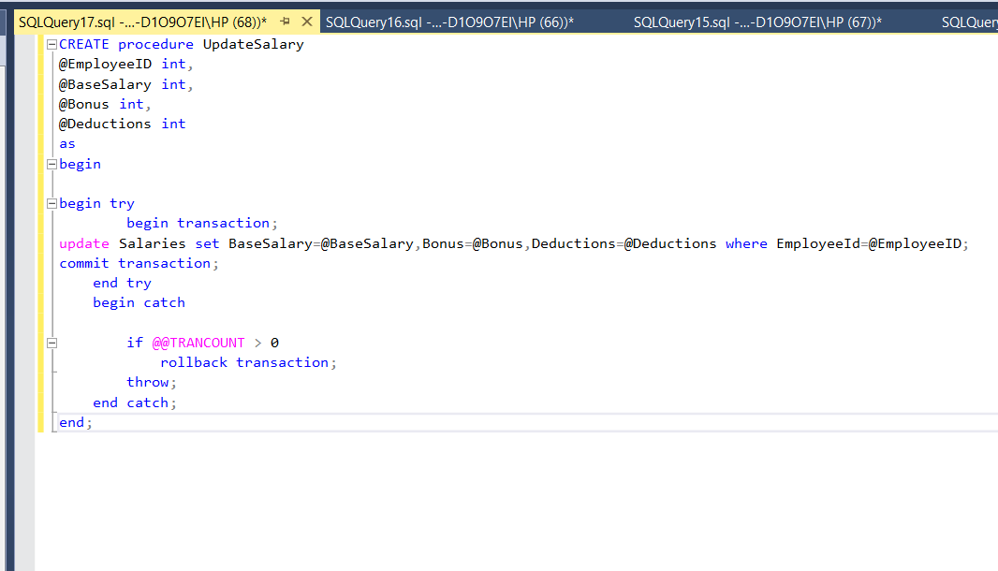

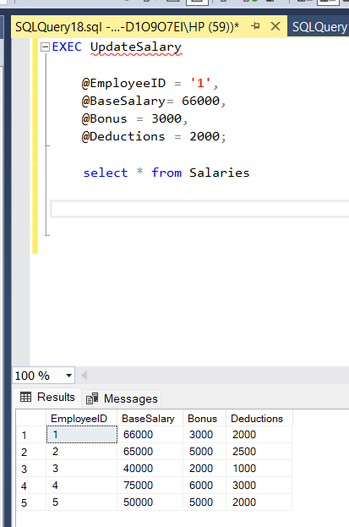

**4.Views:**

A view that combines Employees ,Departments, and Salaries to provide a detailed report of employee salaries with department name and net salaries

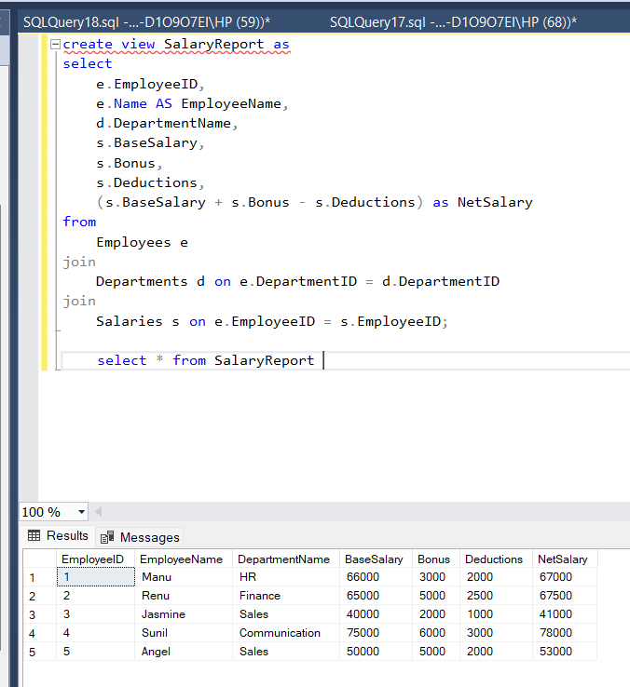

* A view that lists employees earning above a certain threshold

